Economic impact of the reuse of raw wastewater in irrigation: meso-economic survey on the largest perimeters of Morocco

Author ¹, Author ², Author ³.

Affiliation1
Affiliation2
Affiliation3

Abstract(300 word limit)
In Morocco, wastewater is continuously discharged without pretreatment downstream of urban centers and widely reused in agricultural irrigation, especially where water resources are limited and soils are deficient in organic matter. This constitutes a potential risk for the health of the population. Thus, this work has set as an objective to calculate the cost of damage caused by waterborne diseases in order to estimate how much they weigh (monetary burden) on one of the largest perimeters of Morocco where the reuse of raw wastewater is very responsive (Meknes, Khemisset, Tiflet and Sidi Allal El Bahraoui). For this purpose, we opted for a meso economic analysis that would provide aid to public health policy decisions in a given region. To calculate the cost of damage caused by waterborne diseases in the provinces of Meknes and Khemisset, the same method used by the World Bank and the World Health Organization (WHO) in 2001 was used: Cost of damage caused by waterborne diseases = Cost of treatment (direct cost) + Cost of time spent caring for sick children (indirect cost). Then we compared the cost of damage caused by waterborne diseases with the cost of wastewater treatment in the two provinces. The results obtained clearly show that waterborne diseases are a real health problem, and weigh heavily on both provinces, particularly in the province of Meknes, despite the decrease in their incidence over time. The monetary quantification of the damage caused by waterborne diseases cannot be completely accurate because of the under-reporting of cases (the use of traditional medicine which escapes any reporting system.

Please insert Image/Figure

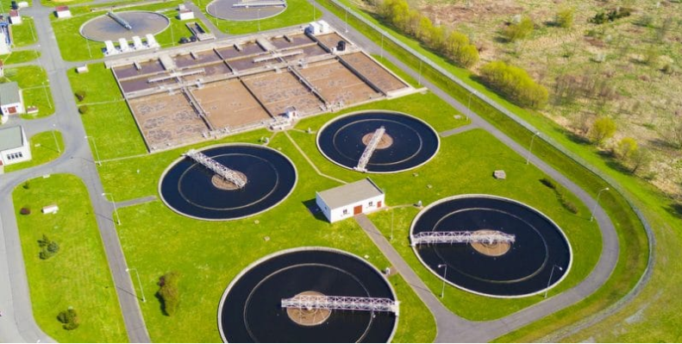
Recent Publications (maximum 5)
- M.Messaoudi, M.Douma, N.Tijani, L.Messaoudi, Heliyon. 7 (2021) e06837.
- M.Messaoudi, M.Douma, N.Tijani, L.Messaoudi, Heliyon. 7 (2021) e06837.
- M.Messaoudi, M.Douma, N.Tijani, L.Messaoudi, Heliyon. 7 (2021) e06837.
- M.Messaoudi, M.Douma, N.Tijani, L.Messaoudi, Heliyon. 7 (2021) e06837.
- M.Messaoudi, M.Douma, N.Tijani, L.Messaoudi, Heliyon. 7 (2021) e06837

